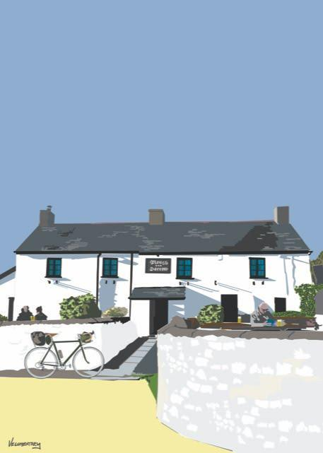

**Foreword by Jack Thurston. Author of the ‘Lost Lanes’ series of cycling guidebooks**

**WHEN CYCLING WAS FUN**

A guide to cycling round all the country pubs in the Vale of Glamorgan

21 of them. In a weekend.

Paul Donoghue

INSIDE FRONT COVER

When Cycling Was Fun. A guide to cycling round all the country pubs in the Vale of Glamorgan.

Publishers: Independent Publishing Network

ISBN: 978-1-80049-655-2

Cover picture: The Plough and Harrow Monknash by Chris Anderson. Velomentary.com

Text, photographs and illustrations: Paul Donoghue

You can contact me about any aspect of this book at

[pauldonoghue2538@gmail.com](mailto:pauldonoghue2538@gmail.com)

www.whencyclingwasfun.com

**CONTENTS**

**EXPLANATION**

**INTRODUCTION**

**PREPARATION**

**THE ROADS**

**THE PUBS**

**HOW TO GET THERE**

**CYCLING ON YOUR OWN**

**STAYING SAFE**

**THE ROUTES**

**PLACES TO STAY AND OTHER USEFUL PLACES**

**PLEASE NOTE**

Country pubs can usually be relied upon to be a constant in a changing world. However, sometimes they can change management, move their opening times, or alter what they offer the thirsty cyclist. There is nothing worse than arriving at a pub hot and in desperate need of beer, to find it’s been closed for refurbishment. I visit all these pubs regularly in the name of research (I know, sometimes life is tough) and will put updates on the website [www.whencyclingwasfun.com](http://www.whencyclingwasfun.com) if I think anything is worth mentioning about the pubs or anything else on these routes. This will ensure you always have a satisfying trip.

GPS files for the routes can also be found on the website.

FOREWORD by Jack Thurston

The pub is a national icon, some might say the envy of the world. Our pubs – and at the last count there were upwards of 40,000 of them – are also local landmarks. And there’s nothing like arriving at a pub on a bike, under your own steam and having worked up a thirst.

When planning my own bike rides, good pubs are always among my lodestars, from old fashioned affairs with a serving hatch and beer from a jug to rambling half-timbered coaching inns to swish dining pubs with plush bedrooms upstairs to remote, stone-built drovers’ rests. A pub is a place to be revived in body and spirit, to quench a parched and dusty mouth on a hot summer's day, to relax in a garden under the shade of a parasol, or, in bad weather, warm up and dry out by an open fire.

Adapting to the changing times, more and more pubs are upping their food game. This is a boon to hungry cyclists who can safely devour a Sunday roast followed by a sticky toffee pudding without a shade of remorse since all those calories will instantly be burned off on the ride home. What’s more, we can wash it all down with a second pint, safe in the knowledge that the police have no powers to require cyclists to take a breathalyser test. Having said that, it is always wise to drink in moderation if you still have some distance to cover. A two-wheeled pub crawl is unlikely to end happily.

The Covid-19 pandemic has hit our pubs hard, with months of enforced closures during lockdowns and the heartbreak of having to pour gallons of good beer down the drain. And the rest of us have lived month after month wondering whether our favourite locals would survive the crisis at all. More than ever our pubs need our help- to put it more bluntly, our money- to get back on their feet. And cometh the hour, cometh the man. Paul Donoghue has made it his mission to spark a pedal-powered recovery plan for the pubs of the Vale of Glamorgan.

Don’t let the lighthearted banter of Paul’s prose deceive you, the booklet you hold in your hands is the product of years of dedicated, painstaking research, both to design brilliant routes around the gently rolling countryside of the Vale and to seek out the very best real ale, craft lagers and hearty pub grub available to humanity- it’s a tough job but somebody had to do it. So dig out that bike that’s been gathering dust in the garage, put some air in the tyres and may the summer of 2021 go down in history as a summer of pub runs. Pob lwc a iechyd da!

Jack Thurston. Author of the Lost Lanes series of cycling guidebooks. lostlanes.co.uk

**EXPLANATION**.

I’ve been cycling to country pubs for over forty years. Over this time, while I’ve been sitting outside with my beer, I’ve noticed fewer and fewer cyclists going to the pub, and more of them cycling past at speed. It doesn’t seem right.

This guide is intended to encourage people to slow down a bit and cycle to pubs in the country. I’ve counted 21 proper country pubs in the beautiful countryside of the Vale of Glamorgan, and it's not difficult to visit them all in a weekend by bike, cycling entirely on quiet lanes. I’ve devised a weekend of cycling where you pass all of them, and you can visit as many as you like. I hesitate to use the word ‘challenge’, with its connotations of blood, sweat and tears, but visiting them all in a weekend is an uplifting experience. Just don’t have a pint in each one.

Please note, this is a pub cycling guide. There are plenty of other books and guides to cycling quickly. I’m not against lycra, protein shakes, or velo-cafés. They have their place. But this guide is concerned with cycling slowly, in the countryside, to pubs.

**INTRODUCTION**

I first cycled to a pub in 1976. I was with a friend and two girls that we'd met at a summer fayre in Cardiff. It was about an hour's ride, and for hydration purposes we had a bottle of Babycham that I'd won at the tombola. No questions were asked about our ages (I was 17 but looked about 12), and we added our bikes to the many others leaning against the wall of the beer garden and settled down with our drinks.  
  
There were a lot of bikes there. The cyclists looked like everyone else, big hair, T-shirt and jeans, drinking beer. If they wanted to eat, they would have a packet of nuts from the bar, pulled from a board on which a page 3 model would become slowly more exposed. None of them knew exactly how long they took to get there or what the distance was. They didn't have a little button to press on their watch. They rode bikes because they wanted to get to a pub in a timely manner, and their priorities were beer, Big D nuts and maybe a cigarette.   
  
We never saw the girls again, and the perry burst in my duffle bag on the way home. The pub is still there though, the Maenllwyd Inn, situated in the countryside near Caerphilly, and it remains a very good country pub. It hasn’t changed for at least a hundred years.

If you pass the Maenllwyd, or any other country pub on a sunny day now you won’t see many bikes leaning against the wall. You may occasionally spot a couple of shiny carbon fibre cycles carefully placed somewhere soft to avoid the possibility of scratches, and if you look around you will immediately ascertain who the owners are, because they don’t look like everybody else. They are dressed from head to toe in tight lycra, and they’ve got a piece of metal sticking out of the bottom of their shoes so they can’t walk properly. They’ll be carefully looking at their little bike computers and calculating how long before they need to set off again to achieve their goal of so many ‘K' in a certain time. You may see one tentatively asking at the bar if he can have a skinny latte. They are not like the cyclists I saw in 1976.

At least they’ve come to a pub. Sadly, the majority of cyclists don't even have their breaks in pubs anymore, because they don’t venture onto the quiet lanes where a good country pub can be found. Instead, they travel on main A and B roads because the tarmac is smoother and they can maintain a decent speed. They leave a record of their ride on an online site, so everyone can see how quickly they’ve gone, and if they go really fast, Strava will give them little pretend medals, which they collect like children. Even if they pass a pub, they don’t go in because they don’t believe that it can offer what they need, which is coffee with a funny name and a high carb snack. Anyway, they feel out of place in their tight spandex, with that unsightly bulge, so they have their breaks in velo-cafés where they can mix with people who look like them, clip clopping to their table in their special shoes as if they’ve got rickets, balancing a latte and a piece of carrot cake that has set them back eight pounds fifty. Or they have a takeaway from Starbucks, sipping a pint carton of boiling hot liquid through a tiny hole in the lid.

Reader, is this what you want? Is this how you choose to live your life? Rushing, going nowhere, concerning yourself with records and times that don’t matter? The constant crushing disappointment of not improving on your ‘PB'? Breathing in tiny particulate matter from exhausts that get into your brain and make you even grumpier? Sucking gel bars from a lumpy pocket in the back of your spandex shirt?

You’re competitive, I know you’re competitive. It's in your make-up. You didn’t get to be CEO of a large company/ employee of the month/ 1986 class hide and seek champion without that ruthless streak. I don’t want to stop you doing all that. Cycling is a great pastime. It keeps you fit and healthy. But... there is another way.

The country pubs that I visited 45 years ago are still there, many of them substantially unchanged for hundreds of years, and each one unique. The quiet lanes are still there too, where you may see a car or tractor only every twenty minutes or so. You will see the same things that I saw then, trees, birds and fields. You will hear – well, nothing really. A bird tweeting, a cow, maybe a sheep. Probably a sheep in Wales. You can still do what people used to do - get on your bike, leave your worries behind, and cycle to a pub in the country. Leave your GPS device at home. Leave your watch at home, get to the pub when you feel like it. Stop to look at interesting things, take a picnic, take your time peeling your hard-boiled egg and eating your cheese sandwich. Relax in the pub in the knowledge that you’re part of history, one of the thousands of people who have travelled there over hundreds of years, seeking only liquid refreshment, and maybe a pasty. Let the history and the atmosphere of the pub sink into your being, and leave the place a more contented, happier person. Some of these pubs are having a tough time at present, so you are supporting them and the farmers supplying them with food. Your money is going back into the community.

I’ve written this for anyone who wants to take part in this, my favourite pastime, Cycling to a Pub, Having a Drink and Maybe Something to Eat, and Cycling Back Home. You might be a fast Strava boy or girl, or you may not have gone to a pub on your bike because you didn’t know where to go, or you thought maybe you would have to negotiate busy roads. Perhaps you think that to be a cyclist nowadays you have to wear all that tight fitting clothing. This is for you all.

**PREPARATION.**

Not much, to tell you the truth. You’re just popping out to the pub. First, a bike would be good. Any bike will do, as long as it has brakes. It might also be a good idea to have a jumper if it gets chilly and something to keep you dry if it rains. Get some lights just in case it takes longer than you think and you have to come home late. You may want to take a picnic, or at least a snack so you don’t get hungry on the journey. Or you might plan on eating at the pub. It’s up to you.

You don’t need to do much planning, I’ve sorted out the routes for you. I’ve spent ages drawing them. Do the one that suits you best, you can just do some of it if you like, and you can visit as many or as few pubs as you decide to. It's difficult to get lost because there are signs everywhere telling you where the next village is. If you’re really unsure, buy an Ordnance Survey map. It's number 170.

Also, make sure that you have a spare inner tube or a bike repair kit. You'll need tyre levers and a pump as well. I know the quiet and solitude of the countryside does wonders for your troubled mind, but you'll soon be back to a seething mass of self-recrimination and despair when you’re stuck miles from anywhere with a flat tyre and no way to repair it. I've also given details at the back of the guide of places that can do running repairs to your bike should anything more serious happen.

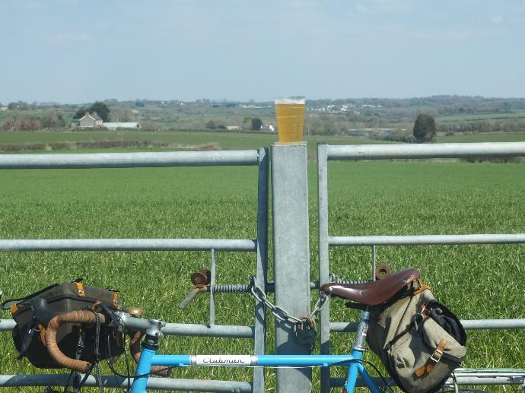

**St Brides to Wick**

Relax and enjoy the views. You’re in no hurry. Rehydrate with your favourite liquid.

**THE ROADS**

They’re quiet. I have avoided A and B roads on these routes. You may have to go on a main road for a maximum of 200 yards once or twice- even then there is usually an alternative lane, although it may be a bit muddy in the winter. Anyway, you can always get off and walk on the grass verge on the busy bits. Apart from that, you will not be bothered by much traffic. I’ve done a few traffic counts on different routes and you’ll have an average of six cars or tractors passing every hour. People stroll these lanes for a bit of exercise, they’re always in the middle of the road. Get a bell to sound or politely shout out to encourage them to move out of the way. Do it when you’re a few yards away or you’ll frighten them to death.

Also, horses. People ride their horses here. Now I’m not a horse expert, but on cowboy films, the horses go really fast, especially when there’s a posse going after the bank robbers. That’s not the case round here. I would estimate two miles an hour. It’s funny, the riders could walk to wherever they’re going just as quickly, so I don’t really know why they’ve saddled up. But, again, as with pedestrians, when you see them, politely let them know you’re there, or slow right down if they’re coming towards you. They're not that bright, (the horses) and no matter how many bikes they see they still get confused. The ladies riding them – they’re nearly always ladies - will be very grateful if you show consideration.

A warning. Some of the routes are hilly. We can’t avoid hills, because the country itself is lumpy. A lot of cyclists don’t like them, even some experienced riders. Streamlined clothes and hairless legs won’t get you up there any faster - you’ve just got to get your head down and sweat it out. Don’t let the thought of hills put you off though, you’re not in a rush, so go as slow as you like. Think of it as a fun workout- it’s got to be better than the sad spectacle of bouncing around to Joe Wicks every morning. I mean, you can always get off and push if gets too hard.

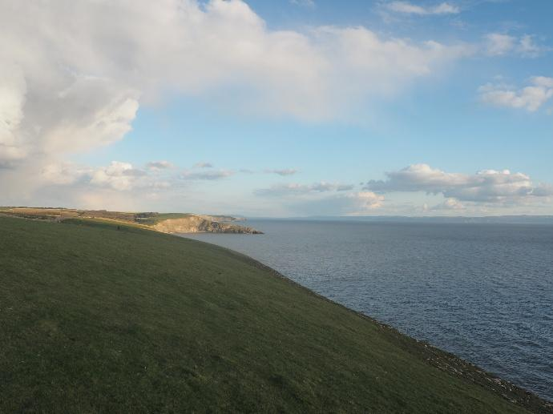

**St Brides to Southerndown**

There are plenty of impressive views on these rides. You can stop and have a dip in the sea at Southerndown and Ogmore.

**THE PUBS**

I have included 21 pubs that I deem to be bona fide country pubs, all situated in the Vale of Glamorgan. To be a country pub it will have to be firstly, in the country. You shouldn’t be able to hear traffic noise, it can’t be in a built-up area, and you should be able to get there from anywhere in the Vale without travelling on busy roads. There will not be a Starbucks for miles. These are tough rules but a country pub is a country pub. There is, for example, a well known pub called the Blue Anchor in Aberthaw that I haven’t included as you just can’t get to it without riding on a busy road. Sorry. There are two good pubs in Aberthin, close to Cowbridge, that are set on the A48. And any pub in Cowbridge, Llantwit Major or any large village, I don’t consider to be in the country.

The pubs I have included are excellent. They are all different, which is of course the brilliant thing about them. Each one has its own character, some are unfussy country boozers, others will be gastropubs where someone in uniform shows you to your seat and asks how your food is all the time. Some have the menu scrawled on the wall while others have a wine list to peruse. They are all friendly - everyone will make you welcome, especially if you’re on a bike. You will like them all, but you will end up with your favourites. A bit like having children I suppose.

Now I’m sure you are a dignified, discerning individual, but I am including some guidance regarding behaviour which you may find useful if cycling to a pub is new to you.

-Wear what you like, lycra is fine, really. I mean, if having your privates on display embarrasses you to that extent, you can wear some baggy shorts I suppose, but these are hardy farming folk and they’ve seen it all before.

-Don’t go on and on about Strava segments or feet of ascent. If you have to look at your watch for this information, be discreet. Nobody likes a show off.

-Don’t talk too loudly about your forthcoming skiing trip, or how much your house has increased in value over the last twelve months. I know you’ve worked hard, but keep that for round the water cooler. Just enjoy the conversation at the bar.

-Sucking on a gel bar or chewing one of those birdseed cakes in the pub is considered rude, especially if there are pork scratchings or nuts you can buy. There won’t be a girl in a bikini on the board now though. Those days have gone.

-Before you leave, don’t hand the bar staff your water bottle with a bit of special powder in the bottom, and ask them to fill it up from the tap for nothing. They survive by selling you stuff to keep you hydrated, there is pint after pint in barrels to fill up on. If you can’t get to the next pub without drying up, then buy squash or something and decant that into your bidon.

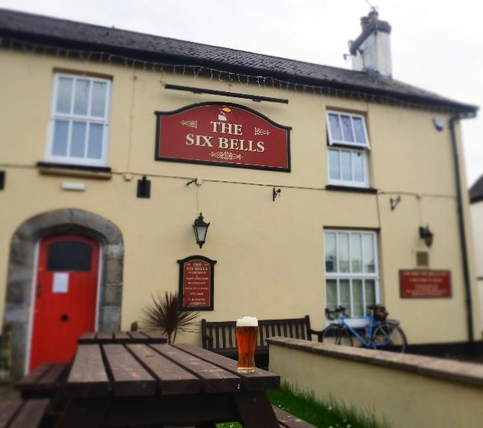

**The Six Bells Penmark**

A proper country pub, next to a church and a ruined castle.

**HOW TO GET THERE**

You can start anywhere on the circular routes, or mix and match, as they intersect. I have started the routes at Llantwit Major train station so that if you’re travelling to the Vale, you can use this as your base. You can travel on any train with a bike and the bike will be free. Also, although the pubs at Llantwit Major aren’t any of the country pubs as delineated in my definition, there are 5 excellent ones there where you can have a drink or something to eat before getting the train home. If you’ve alighted at Bridgend Station then you can pick up the trail at St Brides, only 4 miles away. Go south out of the station, and pick up the B4265 for Llantwit Major and Cowbridge. Go straight across the mini roundabout and into St Brides. Pick up the route at The Farmer's Arms or The Fox.

**NOTE: CYCLING ON YOUR OWN, OR IN THE WINTER, OR IF IT’S RAINING.**

Cycling off to the pub in the summertime with your chums or partner is a great thing to do. But remember, you can cycle to a pub at any time of year - I’ve had some of my best trips in the cold and rain. You just need to be wrapped up warm and with some waterproof clothing. So, get out in the different weathers. Feel the rain on your face, and your toes getting colder and colder. This is freedom. I know people use machines to go on ‘virtual’ rides whenever it’s a bit nippy out but it’s not the same is it? In the garage squashed next to the lawnmower, pretending you’re going up a hill in the Soloman Islands until little Tarquin comes barging in asking you to help with his homework. Get out of the house mate. Do some real cycling. Warm up beside a real fire in a proper pub.

You can also go off on your own. Sometimes there will be nobody to go with, and other times you may just want to have the freedom to stop for a break whenever you want, without a big discussion about whether there’s a better place for a picnic over the next hill, etc. And I know some people don’t like going into pubs on their own (you know - people are wondering why I haven’t got any friends, or if I’ve been stood up, or if I’m an alcoholic). If you’ve cycled there, it’s clear that you’ve stopped for refreshment on your journey, as people have done at pubs for hundreds of years. You’ll fit right in and be made to feel welcome.

**STAYING SAFE**

All the roads on these routes are very safe. Traffic does not travel at any speed, because the roads are winding, and because there is always the possibility of a horse or pedestrian round the corner. Due to the lack of noise, you can hear a car coming from a decent distance away. However, you do get some traffic on these lanes, because that’s what they’re for, so be aware that you do need to keep your wits about you, which can be difficult after too much alcohol. Although there is no legal limit for blood alcohol as in driving a mechanically propelled vehicle, it is an offence to ride your bike while drunk - if you’ve drunk so much that a police officer thinks you’re not properly in charge of the bike, or you’re a danger to yourself and others, you can be fined.

Now I don’t want to be a killjoy, and having a pint or two in a pub in the country is a great thing to do, but you need to stay safe. If you’re visiting all the pubs on one of these routes in one day, be aware that soft drinks, coffee, half pints or shandies are quite acceptable; you can’t be having 11 pints and thinking you can safely navigate thirty odd miles. You’ll end up just being a burden on your companions, fighting, trying to kiss strangers. You know the sort of thing. Save that for the rugby.

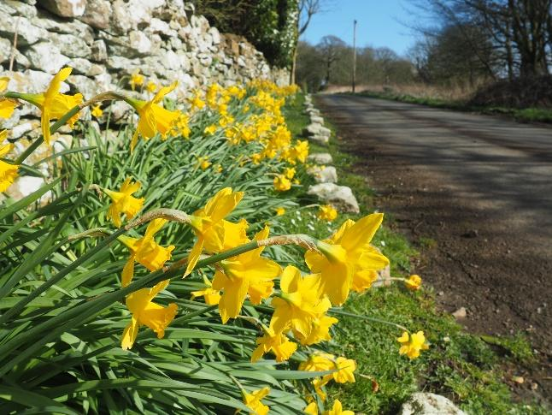

**Llampha**

Most of the roads are very quiet.

**DAY 1. 33 MILES.**

**The Victoria Inn Siginstone**

**The Carne Arms Llysworney**

**The Sycamore Tree Colwinston**

**The Star Inn Treoes**

**The Barley Mow Graig Penllyn**

**The Red Fox Penllyn**

**The Farmer's Arms St Brides**

**The Three Golden Cups Southerndown**

**The Fox St Brides**

**The Lamb and Flag Wick**

**The Star Inn Wick**

**The Plough and Harrow Monknash**

**The Horseshoe Inn Marcross**

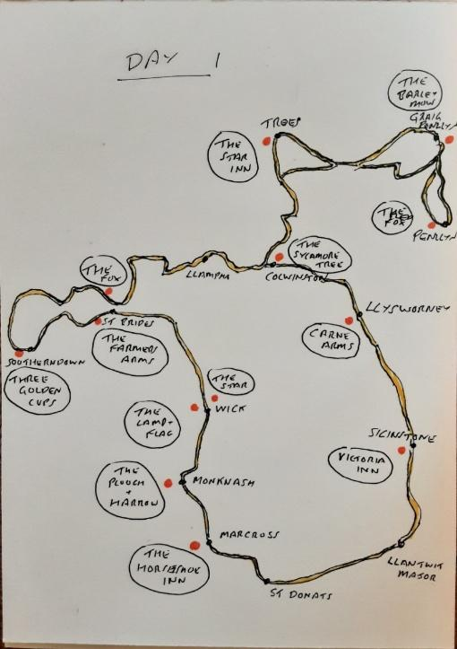DAY 1 PUBS

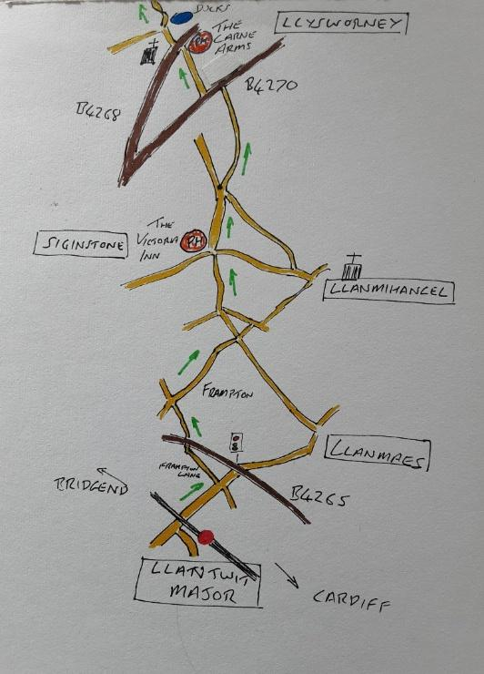Llantwit Major-Siginstone-Llysworney

**ROUTE 1.**

**LLANTWIT MAJOR TO SIGINSTONE. THE VICTORIA INN**

Come out of the station and turn right at the mini roundabout and past a set of lights. Go under the railway bridge and just before the lights at the junction to the B4265 turn left down Frampton Lane. Turn right after a couple of hundred yards past Frampton.

Everywhere you go in this part of the Vale there are signs for Frampton. I counted eight. But there’s no village sign, you only know you’re in it because there’s an old broken down stately home on your right and about three houses. Frampton holds the record for having more signs pointing to it than there are people in it. This is actually Great Frampton. There’s a Little Frampton somewhere. How tiny must that be?

Go through Frampton, left at the junction and into Siginstone and The Victoria Inn. It's nineteenth century, and looks like a proper country pub. It’s got a lovely old fireplace, and everything is authentic. The restaurant serves decent wholesome food, although you won’t want to eat yet, you’ve just started. Your breakfast hasn’t properly gone down. But, choose a drink from the many available and find somewhere to sit and relax.